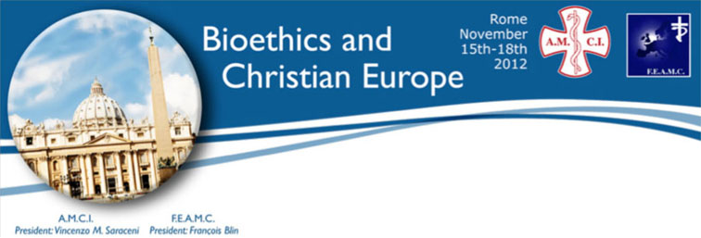

FEAMC-AMCI CONGRESS

Rome, 15-18 Novembre 2012

Bioetica ed Europa Cristiana

La Bioéthique et l'Europe chrétienne

Bioethics and Christian Europe

___________________________

RIASSUNTI

RÉSUMÉS

ABSTRACTS

___________________________

Mercoledì 14 / Mercredi 14 / Wednesday 14

18.00: Board meeting of FEAMC

in Residenza di Ospitalità Protetta, Policlinico Gemelli

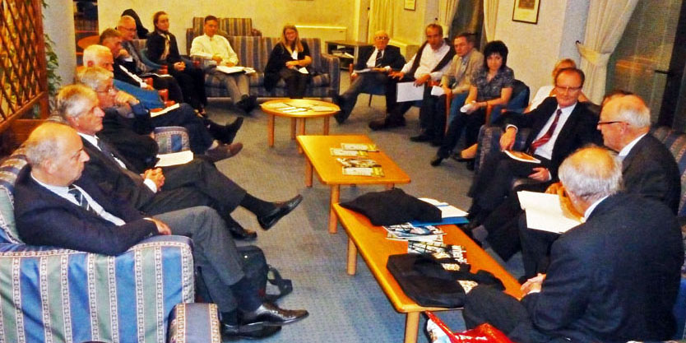

Vincenzo Defilippis, Rudolf Giertler, Christian Brégeon, Ermanno Pavesi, Dirk Pranger, Jozef Glasa, Helena Glasova, Istvan Farago, Jasenka Markeljevic, J Marek, D Cunha e Sà, Kanstantin Balaboshka and his wife, Anna Greziak, Bernard Ars,

Mgr Valentin Pozaic, Hans Stevens, Francois Blin

___________________________

Giovedì 15 / Jeudi 15 / Thursday 15

9.00
Assemblee generali FEAMC e AMCI
Assemblées Générales FEAMC et AMCI
FEAMC and AMCI General Assemblies

___________________________

11.00: Session 1

Radici e concezione cristiana della bioetica in Europa

Racines et conceptions chrétiennes de la bioéthique en Europe

Christian roots and conception of bioethics in Europe

(Chiara Mantovani - Paul Deschepper)

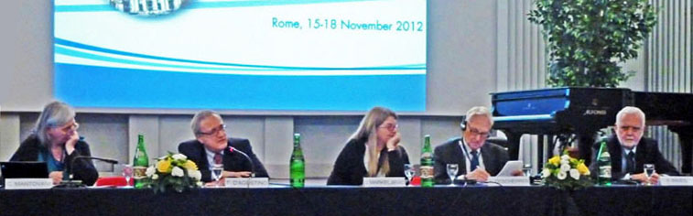

Session 1a: Chiara Mantovani, Francesco d'Agostino, Jasenka Markeljevic,

Paul Deschepper, Ermanno Pavesi

1 - Alessandro de Franciscis (Italia)

Scienza e miracoli / Science et Miracles / Science and miracles

(non ricevuto / non reçu / not received)

___________________________

2 - Francesco d'Agostino (Italia)

Etica laica ed etica cristiana / Ethique séculière, et Ethique chrétienne

Secular ethics and christian ethics

(non ricevuto / non reçu / not received)

___________________________

3 - Jasenka Markeljevic (Croatia)

Dignità della vita umana. Prospettive alla luce della Fede e della Scienza

La dignité de la vie humaine.

Perspectives à la lumière de la Foi et de la science

The dignity of human life. Prospects in the Light of Faith and Science

Dignity of human life in the light of the aura of sanctity and divine beauty is absolutely a value of freedom of making responsible and ethical decisions in all areas of human activity, especially in science and medicine. Today at the beginning of the 21st century, we are faced with the crisis of faith, culture, consciousness, conscience and moral value system, which is reflected on the different concepts of the dignity of human life from the perspective of faith and science. Modern science allow the realization of previously difficult scientific ideas that raise many ethical and moral questions. Both science and faith share the same fascination with the mystery of creation and its creator: the science explains with "how" and faith corresponds to "why".To protect the dignity of human life in the light of faith and science is one of the biggest moral challenges facing our civilization and it is a responsibility towards the future of all life on earth. Consciousness of human being formed in the spirit of authentic expression of absolute truth in It is formed in the spirit of authentic expression of absolute truth in ethical and moral attitude of our civilization directly affects the formation of values in protecting all aspects of existence, dignity of human life in consonance with faith and scientific achievements.

___________________________

4 - Ermanno Pavesi (Switzerland)

Originalità della riflessione bioetica in Europa

Originalité de la réflexion bioéthique en Europe

The originality of bioethical reflection in Europe

Le radici della coscienza e della civiltà europee, caratterizzate dal rispetto per la dignità e per i diritti dell’uomo, risalgono all’Umanesimo rinascimentale. Effettivamente i maggiori esponenti dell’Umanesimo, tra i quali Francesco Petrarca e Coluccio Salutati, hanno difeso la dignità dell’uomo contro le concezioni deterministiche e naturalistiche che dominavano la medicina del tempo, sostenendo invece che l’uomo, fatto a immagine e somiglianza di Dio e fornito di un’anima immortale, deve subordinare il bene del corpo a quello dell’anima e quindi deve anche subordinare la medicina alla teologia, alla filosofia, soprattutto alla filosofia morale, e alla giurisprudenza.
14.30: Session 1b
(Rudolf Giertler - Domenico Di Virgilio)

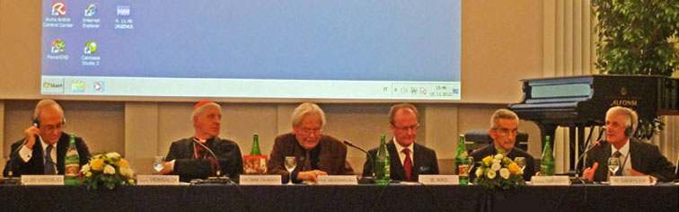

Session 1b: Domenico di virgilio, Card. Giuseppe Versaldi, Hans-Bernhard Wuermeling, Bernard Ars, Mgr Jacques Suaudeau, Rudolf Giertler

5 - Card. Giuseppe Versaldi (Italia)

Fede e bioetica

Foi et bioéthique

Faith and bioethics

(Conclusione)

L'alternativa a questo dialogo tra le scienze con il contributo della fede attraverso un metodo razionalmente accettabile annullerebbe di fatto l'iniziale buona intenzione della scienza medica di avere dei criteri etici a supporto dei loro interventi sulla vita umana. La sola ragione di per sé potrebbe bastare a trovare quella comune ed universale visione della natura umana necessaria per stabilire un ponte tra le scienze naturali ed i principi etici che ne dirigano l'azione. Ma, come la storia dimostra specialmente la storia moderna, proprio attraverso la ragione si è giunti a negare persino la possibilità di avere una visione naturale universalmente condivisibile con conseguente svuotamento di ogni possibilità di fondare dei principi etici. Si tratta, come rilevava Giovanni Paolo II nella citata enciclica Fides et ratio, di una “crisi di fiducia, che il nostro tempo sta attraversando, circa la capacità della ragione” (n.84) e che ha portato ad alcune linee di pensiero debole che il Papa riconosce nell'ecclettismo (collezione acritica di diverse idee senza connessione sistematica), nello storicismo (la verità dipende dipende dalla sua adeguatezza ad un determinato periodo storico di cui assolve il compito), nello scientismo (la sola conoscenza vera è quella delle scienze naturali), nel pragmatismo (esclusione di ogni riflessione teoretica o etica nel fare le decisioni) e, infine come inevitabile conseguenza, nel nichilismo (rifiuto di ogni pretesa verità oggettiva).

Non v'è chi possa negare che questa lettura che il Beato Pontefice faceva alla fine del secolo scorso (1998) non solo sia ancor valida, ma su quella deriva della ragione si sono fatti notevoli passi in avanti con la crescente affermazione del criterio della libertà da ogni vincolo etico che porta a legislazioni sempre più permissive in nome della abolizione di qualunque “discriminazione” che deriverebbe dalla affermazione di valori che limitino l'assoluta libertà individuali. In nome di presunti e indimostrati “diritti” si vanno sempre più affermando processi di cambiamento dei capisaldi della antropologia finora comunemente accettata e presentati come un inarrestabile “progresso” della società democratica ed evoluta.

L'auspicio che formulo, e che questo convegno può in parte favorire, è che torni la fiducia nella ragione umana aperta alla ricerca della intera verità e al contributo delle scienze metafisiche e teologiche, le quali, a loro volta, si rendano sempre più capaci di essere comprensibili e credibili agli uomini del nostro tempo. La bioetica, impostata su un severo metodo razionale, può dare un notevole contributo nel quadro della nuova evangelizzazione in cui la Chiesa intera è impegnata e in cui si inserisce l'anno della fede voluto saggiamente e profeticamente da Benedetto XVI.

___________________________

6 - Hanna-Barbara Gerl-Falkovitz* & Hans-Bernhard Wuermeling** (Germany)

La biotecnologia e la bioetica come frutti dell’Europa cristiana

La Biotechnologie et la Bioéthique, fruits de la Chrétienté européenne

Biotechnology and bioethics as fruits of Christian Europe

*Institut für Philosophie an der Technischen Universität Dresden (Deutschland) und EUPHRAT, Europäisches Institut für Philosophie der Religion an der philosophisch-theologischen Hochschule "Benedikt XVI" in Heiligenkreuz (Österreich).

**Institut für Rechtsmedizin der Friedrich-Alexander-Universität Erlangen-Nürnberg (Deutschland).

No religion in the world had succeeded to overcome the mythical dread of the numinosity of nature and to gain fundamental insights to learn how to control nature – and to consider the limits of the manipulation of nature as well as of humans. It was only the liberation of humans from the uncanniness of nature, as it was described at first in Genesis 1 and then by Apostle Paul, that brought the possibility to formulate laws of nature to make nature technically controllable. One can assume (according to the philosopher Hans Blumenberg) that islamic natural science, which was leading up to the 13th century, lost its predominance due to an unsolved theological question: The exploration of natural laws, which are also respected by God, seemed incompatible with his omnipotence, which should allow him to put them out of order at any time. Since then, there have been no fundamental contributions of islamic natural science and technology towards a culture of technology. The rapid development of modern natural science and technology in all areas of research, including those concerning human beings, rather comes from the roots of European Christendom.

After all, it was Thomas Aquinas who differentiated – also in the 13th century – between the divine causa prima and the causae secundae, which were regarded as natural laws created by God as a reliable part of his creation. Thus Thomas Aquinas opened to the early occident – at least in theory – a nearly boundlessly liberal handling of nature, according to the mission in Genesis to explore and dominate nature.

The non-Christian world adopted the results of this research and the possibility to dominate nature from the heritage of European Christendom. However, in doing so, it remained blind towards the theoretical precondition that there are limits to the exploration and domination of the nature, including man, because the mission to dominate nature requires ‘shepard-like’ instead of exploitative behaviour, which becomes absolutely clear in the Book of Revelation. In addition, the mission of shepard-like care is an immediate consequence stemming from human likeness to God, which is underlined in Genesis before.

There is an excellent text in the Old Testament where this change to likeness to God with its liberating consequences is described in a challenging way – in form of an unprecedented religious leap. This excellent text is almost at the beginning of the bible (Gen 1, 26-28): “Let us make mankind in our image and likeness.“ It has been shown that the Hebrew expression for image (zelem), which is used here, stands for the cult statue of god in Sumerian and Babylonian texts, but from a jewish point of view it stands for a graven image. Such a cult statue throned in a confined niche of Sumerian temples: The god really lived there, the statue was charged up with his magic presence. This interior room was inaccessible but one was able to see the numen from a distance through a number of doorways. There was only one exception: the annual celebration where the king of Babylon ‘grasped the hand’ of the god Marduk, led him through the town and exposed him to a liturgical duel – Marduk, which stands for life, fights against chaos and death. His ritualistic victory brought benison and fruitfulness to the new year. This impressive and promising cult also took place when Israel was in the Babylonian exile, during its greatest hopelessness and its foreseeable collapse within the surrounding high culture. Just at this time, a Jewish group of priests wrote the Genesis text and it was meant as a provocation to the Marduk-cult, as a liturgical ‘pièce de résistance’. This group of theologians used the word zelem, which – again from a Jewish point of view – had a definitely negative connotation, but now was newly coined to man: Man was perceived as a “graven image” of God, like a statue as his visible image. In addition, this religious quantum leap takes place in spite of the an-iconism (“Thou shalt not make thee any graven image!”, Ex 20,4; Dt 5,8). The interdiction to use a graven image in reverse is used to affirm the only real and the only allowed image of Jahwe – namely man who was created by Him “in His image”. In more conceptual terms, the consequence to Israel’s religious leap is: There is no anthropomorphic theology but a theomorphic anthropology (U. Mauser).

Looking at it that way results in a previously unknown freedom of research, but: There are also limits to the technological dominion of nature – and of man. Those limits are set within the mission of a caring handling of the entrusted creation, in particular of man himself. However, those limits were often not transferred when the results of research and technology were adopted by non-Christian bioethics, because their preconditions were not engraved in the original culture. Technology is adopted easily, while the underlying idea of man is not.

In Christian Europe, godlikeness and the mission to protect creation gave rise to limiting consequences for science and technology – at least in theory. This can be exemplified by numerous bioethical problems, which assume a self-restriction of “making”, such as resistance against artificial fertilisation and instrumentalisation of embryos (eg. saviour siblings), the discourse on brain death, human rights etc.

Where theologically based anthropology is unknown or where it is being denied, researchers and engineers tend to allow their actions to be limited by short-sighted consequentionalist considerations: “What is the more or less direct consequence of my actions and what limits my actions ethically?” On this basis, compromises between Christians and non-Christians can certainly be found to some degree; however, they are rather related to the pure aim of an action (preference utilitarianism) than to its theoretical basis.

The more questions of theoretical importance have to be considered, the more difficult those compromises will become, although it is the answer to the sense of existence (especially connected with illness and disability) that in the end determines the weal or woe of the individual and of mankind.

It will therefore be the challenge of the Christians in Europe at least to make the solely aim-oriented non-Christian bioethics aware of the knowledge about the godlikeness of man and the consequential self-restriction when dealing with the creation. One cannot force anyone to believe. But one can offer the underlying concept of anthropology. Those who are not too superficial will use it in case of need.

This consciousness of the biblical roots of bioethics and biotechnology will also be a contribution of European Christendom to a new evangelisation.

___________________________

7 - Bernard Ars (Belgium)

50 anni dopo il Concilio Vaticano II:

la nuova evangelizzazione e la medicina

50 ans après Vatican II : Nouvelle évangélisation et médecine

50 years after the II Vatican Council: the new evangelization and medicine

*Docteur en Médecine, Agrégé de l’Enseignement supérieur, 68 Av. du Polo, 1150 Bruxelles. arsbernard@hotmail.com

La nouvelle évangélisation est, avant tout, le fait de chrétiens laïcs, témoignant de leur foi dans leur vie quotidienne, dans leur famille, dans leur travail, dans leur entourage, dans leurs engagements publics ou ecclésiaux.

Il s’agit d’un réel défi lancé à tous les chrétiens, pour qu’ils annoncent la foi qu’ils ont reçue, et dont ils vivent, aux hommes et aux femmes qui attendent confusément la « Bonne Nouvelle ».

Cette nouvelle évangélisation requiert que chacun commence par se « ré-évangéliser » personnellement. Et, pour ce faire, chacun dispose de quatre atouts : étudier, vivre ensemble, prier et témoigner.

Par ailleurs, le catholique qui exerce la médecine, de par sa sensibilité vis-à-vis de l’homme souffrant et sa proximité d’avec l’homme fragile, occupe une place de première ligne. Il est libre d’utiliser tous les moyens actuels pour réaliser cet apostolat, mais doit être conscient que rien ne remplacera jamais le témoignage personnel et surtout se souvenir qu’il peut compter sur l’aide indéfectible du Tout-Puissant Christ ressuscité et sur l’énergie souveraine de l’Esprit.

___________________________

8 - Mgr Jacques Suaudeau, PAV (France)

Le istituzioni europee e la bioetica

Les institutions européennes et la bioéthique

European institutions and bioethics

Les deux institutions européennes supranationales, Conseil de l'Europe et Union Européenne, ont affronté régulièrement les questions bioéthiques, le Conseil de l'Europe d'un point de vue plus éthique, en relation avec le respect des droits de l'homme, l'Union européenne d'un point de vue plus pratique et technique. Sans que l'on puisse parler de la constitution par ces deux organismes d'un véritable "cadre bioéthique européen", qui encompasserait toutes les questions et situations qui intéressent la bioéthique, n'en sont pas moins issues de leurs travaux et décisions un certain nombre de données faisant jurisprudence ou permettant d'orienter les législateurs.
Le Conseil de l'Europe qui regroupe 47 pays de la zone Europe, y compris tous les pays de l'Europe de l'Est, Russie comprise, est l'organisation privilégiée de la protection des droits et de la dignité de l'homme, en Europe. Ses décisions ou indications en la matière viennent de l'activité des différents organismes qui le composent (tous localisés à Strasbourg, France): comité des ministres, assemblée parlementaire, comité directeur pour la bioéthique (CDBI) devenu conité pour la bioéthique DH-BIO), et Cour europénne des droits de l'homme. Le document le plus important produit par le Conseil de l'Europe en la matière est la "Convention pour la protection des droits de l'homme et de la dignité de l'être humain à l'égard des applicatiuons de la biologie et de la médecine", plus communément et brièvement appellé "Convention d'Oviedo" (4 avril 1997) qui est un document contraignant (oblige ses signataires à mettre en aplications les principes qu'il contient). L'Assemblée parlementaire du Conseil de l'Europe a débatu pour sa part sur de nombreux thèmes de bioéthique, et en particulier sur celui de l'euthanasie, qu'elle a repoussée (recommandation 1993, 2012), et sur celui de l'objection de conscience des professionnels et des établissements de la santé dont elle a conforté le principe (resolution 1763, 2010). La Cour européenne des droits de l'homme, par ses nombreux jugements, élabore un instrument juridique européen, dans lequel se dessine au long des jugements successifs une tendance à admettre le suicide assisté (Affaire Koch contre Allemagne, 2012) et un certain droit à l'avortement (affaire RR contre Pologne, 2011). La cour ne semble pas favorable par contre à la "Procréation médicalement assistée" hétérologue (don de sperme ou d'ovules, affaire Gas et Dubois contre France, 2012) et à la "grossesse pour autrui" (affaires Labasse contre France, et Mennesson contre France 2011).
L'Union Européenne a son propre groupe d'éthique (Groupe Européen d'Éthique des sciences et des technologies nouvellesa, GEE). La Directive européenne n°98/44/CE du 6 juillet 1998 réglemente la brevetabilité du vivant. Elle affirme que le corps humain et ses éléments ne peuvent faire objet d'un brevet. La Cour de Justice des Communautés européennes (CJCE), par son arrêt du 18 octobre 2011 dans l'affaire C-34/10 Olivier Brüstle / Greenpeace, a réaffirmé que le corps humain ses parties, et donc les embryons humains ne peuvent faire l'objet d'un brevet, rejettant ainsi la demande de brevet pour les cellules souches et leurs dérivés. Elle a de plus donné une définition large de l'embryon humain comme "tout ovule humain dès le stade de sa fécondation" qui rejette la distinction volontiers faire entre "pré-embryon" et "embryon post implantatoire". Union européenne et Conseil de l'Europe cherchent aujourd'hui à mieux coordonner leurs efforts dans le domaine de la bioéthique, ce dont témoignera le protocole sur le trafic d'organes (à venir de la part du Conseil de l'Europe) et les réflexions éthiques plus ou moins communes sur les tests généthiques, les décisions médicales en fin de vie, le dossier médical, les biobanques, la sélection du sexe, les nouvelles technologies (en particulier nanotechnologies, neuromodulation, neurosciences).

___________________________

18.00: Lectio Magistralis

Car. D Tettamanzi (Italia)

Le radici cristiane dell’Europa e la Bioetica

Les racine chrétiennes de l'Europe et la Bioéthique

The Christian roots of Europe and Bioethics
(Conclusione)

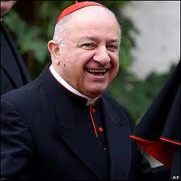

A conclusione di queste riflessioni potremmo chiederci se le radici cristiane dell’Europa sono un semplice riferimento storico per una comprensione delle origini e degli sviluppi della bioetica nel nostro continente o rappresentano una sorgente di ulteriore e più profonda riflessione e azione per il riconoscimento, la tutela e la promozione della vita di tutti e di ciascuno degli europei e per una nuova cultura della salute, della cura e della ricerca biomedica. Se si trattasse di un puro richiamo storico il loro interesse sarebbe assai limitato e troverebbe posto solo nelle accademie e tra gli storici del pensiero etico e sociale.
Ma, ci assicura Benedetto XVI, non è così. Le radici del cristianesimo sono ancora vive tra noi e capaci di alimentare lo sguardo degli europei su ogni aspetto della vita individuale e sociale: «Ciò che ha fondato la cultura dell’Europa, la ricerca di Dio e la disponibilità ad ascoltarlo, rimane anche oggi il fondamento di ogni vera cultura».[24]
La bioetica europea, che ha scritto pagine luminose e coraggiose per difendere la pari dignità e i diritti di tutti gli uomini e di tutte le donne di fronte alla nascita e alla morte, alla salute e alla malattia, alla ricerca scientifica e alle biotecnologie, non deve avere timore di riscoprire Dio quale sorgente inesauribile della vita e orizzonte ultimo, definitivo del significato e del valore di ogni vita umana.
La capacità di affrontare i continui mutamenti nel mondo della salute, della medicina e dell’economia sanitaria che sfidano la ragione e l’esperienza di tutti gli europei richiede un’intelligenza della realtà che si allarga ad abbracciare l’orizzonte non solo delle possibilità dell’uomo e della sua scienza, ma anche ed anzitutto di quelle offerte graziosamente all’uomo dall’amore provvidente di Dio nel figlio suo Gesù, che ci ha amati e ha dato la sua vita per noi (cf. Gal 2,19).
Le relazioni e le testimonianze che ascoltiamo in questi giorni congressuali sono la prova più evidente che la fede non toglie nulla alla multiforme ricchezza dell’ingegno umano dei medici e dei loro collaboratori, ma purifica e orienta la loro ragione scientifica e clinica e guida i loro passi sui sentieri dell’autentico amore verso chi soffre.

E’ questo, ultimamente, lo scopo della medicina, che dobbiamo riscoprire noi e far scoprire ai giovani che in Europa prenderanno il nostro posto.

___________________________
Venerdì 16 / Vendredi 16 / Friday 16

9.00: Session 2

Tavola rotonda sull’obiezione di coscienza

Table ronde sur l'objection de conscience

Roundtable on conscientious objection

(Stefano Ojetti - Bertrand Galichon)

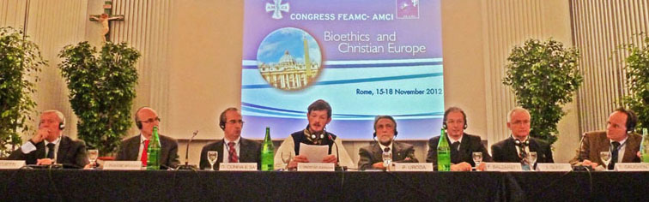

Session 2: Stefano Ojetti, Jorge Buxadé-Arribas, Diogo Cunha e Sa,

Gunnar Grøstad-Johnson, Piero Uroda, Franco Balzaretti, Jozef Glasa, Bertrand Galichon

9 - Francesco Balzaretti (Italia)

In Italia / En Italie / In Italy

(Conclusioni)

Antigone, pur di seppellire il fratello, si era ribellata al divieto del re Creonte; e questo per rispettare una legge morale superiore. Per cui possiamo, senza dubbi, affermare che la morale di questa tragedia, dopo 2500 anni, è ancora tristemente attuale!

Ed infatti anche oggi, come 2.500 anni fa, il Medico (o l’operatore sanitario) è costretto, talora, a ribellarsi ad alcune leggi. Sì perché qualunque cosa venga stabilita dalla legge civile, l’uomo deve poi sempre rispondere alla propria coscienza: non potrà mai obbedire ad una legge che, per lui, dovesse risultare intrinsecamente immorale. Ed è questo il caso di una legge che ammettesse, in linea di principio, la liceità di azioni contro la Vita e contro la dignità umana!

Impedendo l’obiezione di coscienza al medico, si imporrebbero, di fatto, azioni contro la sua coscienza ed egli oltretutto non potrebbe neppure opporsi, per ottemperare alla sua deontologia professionale e ad una legge morale superiore!

Per cui, rispondendo all’interrogativo iniziale di Orazio, noi medici rimaniamo fermamente convinti della nostra scelta e vocazione, che abbiamo fatto in passato, per essere custodi e servitori della Vita; ma chiediamo almeno il diritto di poter agire ed operare, anche oggi, secondo il principio di scienza e coscienza, così come ci è sempre stato concesso, in oltre 2.500 anni di civiltà.

___________________________

10 - Piero Uroda (Italia):

Per i farmacisti / Pour les pharmaciens / For pharmacists

(non ricevuto / non reçu / not received)

___________________________

11 - Gunnar Grøstad-Johnson (Norway):

In Scandinavia / En Scandinavie / In Scandinavia

In the Scandinavian countries conscientious objection in ethically controversial treatment is practised mainly by gynaecologists, general practitioners and midwives. Euthanasia is not lawful in these countries. Lawful conscientious objection applies only to the direct participation in abortion, not to care before or after the procedure.

Informal conscientious objection has been practised by Scandinavian general practitioners in the field of abortion, contraceptives, in vitro fertilization and same-sex parenthood.

Last year the Norwegian health authorities ended the 34 year-old practice of silently accepting that some doctors pass certain tasks on to colleagues of same speciality. The new regulation found support from the National Medical Association, but arose a national debate.

A registration of objecting individuals was attempted, but failed due to internal disagreement among health officials.

Conscientious objection is under increasing pressure in Scandinavia. This happens at the same time as health workers are expressing increased interest in abstaining from taking part in ethically controversial treatment. The reluctance among health workers collide with the governmental ideology on how to solve poverty in the world by securing women’s participation in professional life, and control of own reproductive health.

___________________________

12 - Diogo Cunha e Sa (Portugal)

In Portogallo / Au Portugal / In Portugal

Conscientious objection (CO) in medical practice is important when speaking about abortion (A), as euthanasia is not allowed. Before 1984, A was forbidden. Since that the law allowed it in extreme situations (rape, risk for mother´s life, malformations). In 2007, it was approved a law for free A supported by state (mother´s wish) until 10 weeks. Portuguese Constitution protects human life and CO, but ordinary law and the Supreme Court interpretation go in opposite direction. In the last 50 years the fecundity index has dropped from 3,5 children to 1,32. About 20% of all pregnancies end in legal A (97% invoked mother´s convenience). Since 2007 we have more deaths than births and are lacking 1.250.000 children for generation renovation. Active population is decreasing and less than 40% of workers support more than 60% remain population. CO doctors are not allowed to see women who are in pre abortion reflection period. To be a CO they are obliged to fulfill and signed a form; there is not national registration. About 90% of obstetricians are CO for abortion based only on the mother´s wish. In many hospitals medical staff is not enough and the women are sent to private clinics to have the A done. State pays the bill (500 euros). Up until now there is no discrimination to CO doctors, and they can achieve the specialist title. Usually, doctors do not discriminate each other among them because CO. The main discrimination arises from the law.

___________________________

13 - Jorge Buxadé-Arribas (Spain)

In Spagna / En Espagne / In Spain

L’objection de conscience (ODC) consiste à l’inaccomplissement, de la part de l'individu, d'une obligation légale dont l'exécution produirait une grave lésion dans sa conscience, étant donné que, la réaliser, elle causerait un dommage moral. Celui-ci, c'est le noyau du affaire et il reste en arrière-plan, le fait de ce qu'elle contredit la norme.

En Espagne, dans le dernier quart du XXe siècle, l'ODC commence à être configuré. Le développement législatif espagnol a porté à la liberté de conscience, établie dans la Loi sur la liberté religieuse du 1980 et, dans le domaine sanitaire déterminée à la Loi du 2010 de santé sexuelle et reproductive et l'interruption volontaire de la grossesse, la défense de l'ODC. Aussi même protégée dans les divers Codes Déontologiques professionnels.

L'ODC est une action de grande dignité éthique quand les arguments allégués par le médecin sont sérieux, sincères et constantes, en se rapportant aux questions graves et fondamentales, soutenus dans des raisons professionnelles et éthiques. Durant plus de vingt siècles la Médecine a expérimenté une étape d'autonomie morale radicale. Cette manière de procéder, est le résultat réel de la conscience de ces premiers professionnels gratifiés par le bien qui procuraient à ses patients. Cette forme d'agir il est resté en vigueur dans le monde médical jusqu'aux à la fin du XXe siècle. Le respect pour la vie, l'excellence morale sur le plan medical et des vertus humaines, elles doivent être reprises par la classe médicale, l'acte médical étant récupéré comme un acte de service à l'homme, en fortifiant ses convictions morales et en récupérant la conscience médicale.

___________________________

14 - Jozef Glasa (Slovakia)

In Slovacchia / En Slovaquie / In Slovakia

The present struggle for the "freedom of conscience", albeit being defined as a fundamental, ‘constitutional" human right in Slovakia, as elsewhere, have to be understood as taking place within the complex realities of the "dark heritage from the totalitarian past" and novel, equally dark "postmodern" developments.

Following some period of silence, ‘the debate on the conscientious objection’ started almost suddenly in the second half of 2005, and ‘escalated’ in the beginning of 2006. It led then to the collapse of the coalition government and to early general elections. The igniting moment was refusal of the coalition leader party – Slovak Democratic and Christian Union – to submit to the cabinet the draft text of the Objection of Conscience Treaty that Slovakia was to sign with the Holy See as an implementation measure to the general concordat (ratified in 2002). In an unprecedented move, the European Commission entered the debate by asking its special group – "EU Network of Independent Experts on Fundamental Rights" – to examine the "question of religious conscientious objection as provided in existing or possible future concordats concluded between EU Member States and the Holy See." "An example of such a concordat is the Draft Treaty between the Slovak Republic and the Holy See." In its opinion, the group spelled out a sharp criticism of the draft text.

The ‘conscientious objection’ issue is dormant in the public square now. There is still some cautious hope, however, that the issue could be put forward again successfully in not a too distant future.

___________________________

11.00: Session 3

Generalità sulla bioetica

Généralités sur la bioéthique

General information on bioethics

(Aldo Bova - Ivan Luts)

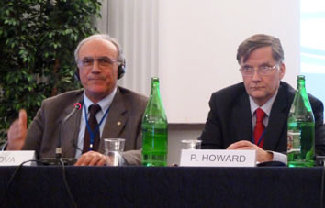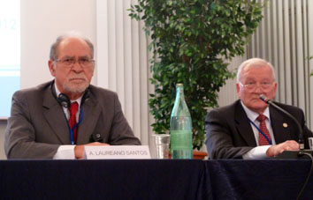
Session 3: Aldo Bova, Philip Howard... Alexandre Laureano-Santos, Ivan Luts

15 - Alexandre Laureano-Santos (Portugal)

Etica nella Medicina delle Catastrofi

Ethique de la Médecine de Catastrophe

Ethics of Disaster Medicine

Affected people by cataclysms need extraordinary efforts to mobilize additional resources that will require an adequate and organized response. Physicians are likely to be part of coordinated operations involving other responders with an effective authority. These are exceptional situations in which normal professional ethics must be brought to the situation. The most dramatic consequences are mainly on the poorest and least prepared populations to react and overcome adverse circumstances, dramatically accentuating their vulnerabilities. By focusing the obligation of communities to protect themselves from the forseeable threats we refer to a necessarily intervention ethical sense. In the face of threats, each community must face up collectively as a moral subject and an active participant. Principles of Social Doctrine of the Church with direct application are: The common good; The defense and protection of human life; The participation; The universal destination of earthly goods; The solidarity and subsidiarity. The principles of Classic Bioethics: The beneficence; The nonmaleficence; The autonomy and justice. In disasters it should be given an emphasis to the nonmaleficence, especially for unprepared personal; do not cause further damage by applying the criteria of maximum safety in all decisions and gestures. We refer to a humanistic preparation of the physicians, meaning multicultural education for understanding other ways of life and privations; meaning scientific knowledge and excellent technical preparation to treat those who are victims of the catastrophes; and spiritual preparation for accompanying all kinds of human suffering.

___________________________

16 - Francesco Ognibene (Italia)

Mass Media e bioetica

Mass media et Bioéthique

Mass Media and bioethics

(Conclusioni)

Vorrei concludere con una frase tra le tante splendide che il Papa ci sta regalando nelle sue catechesi sulla fede alle udienze del mercoledì, e che ci indica la rotta. “In modo molto significativo, il Catechismo della Chiesa Cattolica si apre proprio con la seguente considerazione: «Il desiderio di Dio è inscritto nel cuore dell'uomo, perché l'uomo è stato creato da Dio e per Dio; e Dio non cessa di attirare a sé l'uomo e soltanto in Dio l'uomo troverà la verità e la felicità che cerca senza posa» (n. 27). Una tale affermazione, che anche oggi in molti contesti culturali appare del tutto condivisibile, quasi ovvia, potrebbe invece sembrare una provocazione nell’ambito della cultura occidentale secolarizzata. Molti nostri contemporanei potrebbero infatti obiettare di non avvertire per nulla un tale desiderio di Dio. Per larghi settori della società Egli non è più l’atteso, il desiderato, quanto piuttosto una realtà che lascia indifferenti, davanti alla quale non si deve nemmeno fare lo sforzo di pronunciarsi. In realtà, quello che abbiamo definito come «desiderio di Dio» non è del tutto scomparso e si affaccia ancora oggi, in molti modi, al cuore dell’uomo”. Ravviviamo questa nostalgia della verità sull’uomo e sulla vita, più che mai acuta nel cuore e nell’intelligenza dei nostri contemporanei.

E’ l’uomo infatti che ci interessa, perché in lui vediamo il solo vivente nel quale Dio ha deciso di mostrare il suo stesso volto. Grazie.

___________________________

17 - Philip Howard, MA MD MA LLM FRCP (United Kingdom)

Considerazioni etiche sull’idratazione e la nutrizione

Considérations éthiques sur l'hydratation et la nutrition

Ethical considerations in the provision of hydration and nutrition

The provision of hydration and nutrition should be regarded as an ordinary part of medical and nursing care and as such to be morally obligatory. In recent years the provision of hydration and nutrition by ‘artificial means’ has become an issue of controversy in relation to persistent vegetative state, palliative care and ‘terminal sedation’. The latter is increasingly seen as an alternative to euthanasia. There is a balance between cherishing life and accepting the inevitability of death. Whilst life need not be maintained at all costs and in all circumstances, the deliberate withdrawal of basic life-sustaining measures such as hydration and nutrition with the aim of ending the patients’ life is morally unacceptable.

___________________________

18 - Joaquin-Navarro Valls (Spain)

Testimonianza / Témoignage / Testimony

(non ricevuto / non reçu / not received)

___________________________

14.30: Session 4

Problemi legati all’inizio e alla fine della vita

Problèmes de début et de fin de vie

Problems at the beginning and the end of life

(Almerico Novarini - Anna Greziak)

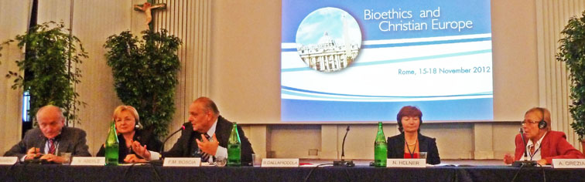

Session 4a: Almerico Novarini, Neda Aberle, Filippo Boscia, Nadiya Helner,

Anna Greziak

19 - Filippo Boscia*, Gabriele D’Amato** (Italia)

La sfida per la vita che nasce al limite della sopravvivenza

Le défi pour la vie qui naît à la limite de la survie

The challenge of life born on the limits of survival

(Conclusioni)

*Direttore Dipartimento Materno-Infantile, ASL BA

**Dirigente Medico Neonatologo, ASL BA

Nel reparto di terapia intensiva neonatale a volte non sono chiaramente identificabili posizioni o atteggiamenti completamente adeguati e soddisfacenti.

Sempre più spesso ci si può trovare di fronte a situazioni borderline in cui le cure rasentano l’accanimento terapeutico o la sproporzionalità delle stesse cure.

Le scelte dei genitori spesso non guardano o non comprendono appieno il travaglio degli operatori sanitari. I loro sentimenti non sono asettici ma impregnati di valori e di emotività diversi. Occorre un’alleanza!

Il medico, guidato dall’etica e dalla scienza, può essere anche giustificato per l’interruzione delle cure inutili, non appropriate, sproporzionate, mentre i genitori di fronte a questa realtà spesso non lo giustificano. Allora il medico deve anche considerare la possibilità di prendere delle decisioni fallibili o imperfette. Se tali decisioni saranno prese seguendo un iter corretto, come già specificato, saranno comunque decisioni eticamente e moralmente sostenibili.

Dal punto di vista degli operatori sanitari è necessario informare, comunicare, trasferire scienza e prassi, ma anche emozioni, nel cuore di tutti i genitori che, accanto al dolore per gli eventi, pensano alla sofferenza del figlio ma anche perché possono percepire e di fatto percepiscono la gioia di un figlio venuto al mondo e la gioia di vivere con lui e vederlo crescere fino a quando potrà essere possibile.

Come l’uomo libero, riportato da Hillman, pensano alla morte per dare più valore alla vita anche se pur breve.

Possiamo concludere dicendo che la Neonatologia fa incontrare l’esperienza della genitorialità nella particolare situazione in cui i vissuti verso un figlio estremamente prematuro posso essere segnati da laceranti contraddizioni.

Ostetrici e Neonatologi convengono sempre che la vita va accettata anche quando si prevede un esito infausto o si prevede la fine.

Noi operatori sanitari cattolici siamo convinti che sempre, anche quando la morte è molto vicina, la vita cresce e si esalta.

La desistenza terapeutica in ambito neonatale lascia ampi interrogativi e obbliga alla esemplarità bioetica delle decisioni che escludono sempre arbitrarie e ardite medicalizzazioni sproporzionali.

___________________________

20 - Bruno Dallapiccola (Italia)

Dalla diagnosi clinica alla medicina predittiva

Du diagnostic clinique à la médecine prédictive

From clinical diagnosis to predictive medicine

(non ricevuto / non reçu / not received)

___________________________

21 - Nadiya Helner*, N. Prokopchuk* (Ukraine)

Aspetti etici del Consiglio Medico Genetico in Ucraina

Aspects éthiques du conseil médical génétique en Ukraine

Ethical aspects of the Medical Genetic Counselling in Ukraine

*Institute of Hereditary Pathology of NAMS of Ukraine, Lviv

Bioethics is the search of ways of the humanization of medicine and the core ethics awareness that is the moral choice and its responsibility.

Moral choice is the process of constant search, doubts, improvement, the eternal battle within and constant personal dissatisfaction

The progressive development of medical genetics, especially a wide range of possibilities for prenatal fetus pathology diagnostics, requires the compulsory introduction of bioethics to the process of medical genetic counseling in Ukraine.

The main questions of medical genetic counseling are:

- does a fetus have the right to be born in any form or to be born healthy?

- does the child born with birth defects have the right to bring a lawsuit against the doctors who did not prevent him from being born and against the mother who did not agree to undergo prenatal diagnosis and termination of pregnancy?

- does the termination of pregnancy not testify to the favor of medical eugenics?

Maintenance of the bioethical principles can be ensured by means of a corresponding legal basis.

Medical genetic counseling is a special kind of interpersonal relations where in one hand is professionalism of a consultant ,in another an interest of a patient (family).

Types of counseling depending on motives:

• etiopathogenetic counseling: the reason is the genetic disorders;

• prospective counseling: prior to conception for families with burdened hereditary anamnesis;

• retrospective counseling: prior to conception for families having a child with birth defects;

• prenatal counseling: after conception, aiming to assess the probability of fetal genetic disorders.

The key principles (rules) of contemporary biomedical ethics are as follows:

• recognition of the personal autonomy, meaning the recognition of the human right to solve the issue of life and health on his/her own;

• preservation of the fair distribution of social welfare (in medicine the equal access for all members of society to medical services);

• preserving the “do not harm” principle;

• following the principle “do not harm and do good”;

• maintaining confidentiality;

• performance of medical procedures according to the medical indications; performance of medical procedures after the reception of the informed, conscious and voluntary consent of a patient.

In the field of medical genetics the interrelations between doctor and patient have their complexity and specificity:

• the information received upon the medical genetic counselling concerns not only the proband himself, but also his family members;

• the results of the genetic researches can predict the future health problems of a healthy person and his family members;

• the genetic research results (the genetic information and choice of any decision) can have the consequences for future generations;

• during the medical genetic counselling, specialists in the field of medical genetics bring the patient (family) the non-directive information.

Some ways of solving the ethical and legal issues in medicine in Ukraine

• informing the population and specialists ;

• broad consideration of these issues in the society;

• creation of the corresponding legislation and subordinate legislation;

• regulation of the work of the corresponding institutions through the system of ethics committees, necessarily with the independent experts in the following specialties: doctors, biologists, lawyers, theologians, ethicists, and health care organizers;

• annual reports of the institutions to the committees on bioethics.

___________________________

22 - Neda Aberle (Croatia)

L'eutanasia prenatale / L'euthanasie prénatale / Prenatal euthanasia

*University Department of Pediatrics, Osijek University Hospital Center, Osijek, Croatia

The gift of life is priceless; therefore those involved in deliberate ending of life bear a tremendous burden of moral responsibility. This primarily refers to the unborn child's mother and father as well as to the physicians and other medical personnel, other family members, and the social community promoting artificial abortion through legal provisions. The physicians are those who should rise in defense of the uniqueness and inimitableness of prenatal development. The term 'prenatal euthanasia' implies therapeutic and eugenic abortion. The physicians and other medical professionals can refuse performing such procedures based on conscientious objection. "Conscience is the man's most secret core and sanctuary where man is alone with God and His voice resounding in his/her inner personality" (Gaudium et Spes, 16). Ethical and moral criteria should include due respect for the human being inviolability in his/her bodily and spiritual integrity and in all his/her developmental stages. All medical institutions have ethics committees, which are useful and frequently irreplaceable in the field of biomedicine and bioethics, however, their judgments represent just a standard agenda (rule of performance) or simply a recommendation, while it is left to the scientist to make his own decision and bear full moral responsibility for it. Man is certainly happier if his horizontal and vertical aspects, i.e. his physical and spiritual dimensions, are brought into harmony. "What's the use of acquiring the entire world, but doing serious harm to one's life" (Mk 8.36).

___________________________

14.30: Session 4b

(Josef Marek - Franco Splendori)

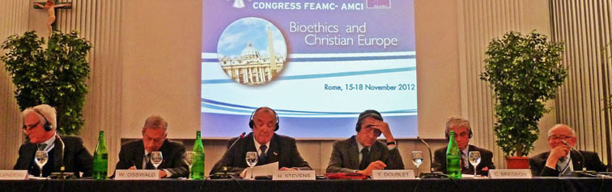

Session 4b: Franco Splendori, Walter Osswald, Hans Stevens, Yves-Marie Doublet, Christian Brégeon, Josef Marek

23 - Christian Brégeon (France)

Demografia ed epidemiologia degli anziani per gli anni 2020-2030.

A quali problemi bioetici dovremo far fronte

Démographie des personnes âgées pour les années 2020-2030.

A quels problèmes bioéthiques faut-il s'attendre?

Demography and epidemiology of the elderly for the years 2020-2030.

Which bioethical problems shall we face?

Avec une bonne précision, on peut prévoir que les personnes âgées dépendantes seront, en France, deux fois plus nombreuses en 2035 qu’en 2010. Les dépenses liées à la dépendance augmenteront aussi, lentement jusqu’en 2025, plus fortement ensuite, pouvant atteindre +50 à +55% en 2040. Ces projections ne sont pas rigoureusement transposables au reste de l’Europe, mais les tendances, avec des décalages, vont dans le même sens.

L’Etat est plébiscité par l’Europe entière pour un financement plus complet de la dépendance, au nom de la redistribution équitable des richesses, mais l’entraide familiale, prépondérante dans la zone sud, est toujours nécessaire. Les quinquagénaires, très sollicités alors qu’ils ont aussi charge d’enfants, s’inquiètent d’une aggravation de leurs contributions financières et fiscales. L’équilibre entre Etat-Providence et familles risque de compromettre la cohésion intrafamiliale et les valeurs de Charité qu’elle recouvre. Les questions récurrentes sur la fin de vie n’épargnent pas cette population toujours plus âgée et plus nombreuse, où la proportion des suicides est anormalement élevée. L’accompagnement doit suivre exactement les mêmes règles que chez les sujets plus jeunes. Toutefois, certaines demandes d’arrêt de soins, qui témoignent à l’évidence d’un refus motivé et prolongé de l’obstination déraisonnable, ne peuvent pas être ignorées. Les soins palliatifs qui humanisent ces situations délicates doivent aussi aider en amont à la réflexion sur la légitimité de poursuivre une vie considérée comme achevée .

____________________________

24 - Yves-Marie Doublet (France)

Le legislazioni sul fine vita in Europa

Les législations sur la fin de vie en Europe

End of life legislations in Europe

Trends which seem to characterize in Europe outside from Benelux the current regulations on the issue of the End-of- Life:

- Making decisions to limit or discontinue treatment for patients in an advanced or terminal phase and simultaneous providing of palliative care.

- Strengthening of the expression of the will of the patients through their advance decisions.

- Prohibiting euthanasia: Such regulations apply in France, Germany, Italy, Spain and Sweden. More generally 470 million inhabitants of countries which have not legalized euthanasia must be compared with the 28 million inhabitants of countries which have legalized euthanasia.

- Recent initiatives in favour of assisted suicide in United Kingdom and Germany.

Provisions to limit or discontinue treatment for patients in an advanced or terminal phase are defined in France by an Act of 22 April 2005. Concerning unconscious patients in an advanced or terminal phase of a serious and incurable disease who are incapable of expressing their wishes, the doctor may decide to limit or discontinue treatment which is pointless, disproportionate or has no effect other than the artificial prolonging of life. The procedure is a collegiate and transparent one.

German rules are determined by a judgment of the Federal Court of Justice and by Guidelines of the Federal Chamber of Doctors for ill, dying and non dying patients.

As regards Spain the legal framework is provided by the draft law of the Government of 11 June 2011 and the Private Members Bill of 13 December 2011.

In Sweden the rules of 26 April 2010 and of 15 August 2011 of the Agency for Social Affairs and Health set forth the principles on the limits for treatment.

Drafts in favour assisted suicide: a Commission defined in January 2012 principles to underpin a legal framework for assisted suicide in the United Kingdom. German Minister of Justice tabled a draft law 29 August 2012.

Provisions on advance decisions in France, Germany, Italy, Spain and in the United Kingdom set out people’s wishes relating to their end of life and concerning the conditions for limiting or discontinuing treatment.

Applying rules have been introduced in countries with different values, cultures and religions. They have not been imposed by the European Union and the Council of Europe. They arose spontaneously.

___________________________

25 - Hans Stevens (Netherlands)

Le leggi che autorizzano l’eutanasia in Europa e le loro conseguenze. Prevenzione dell’eutanasia

Les lois autorisant l'euthanasie en Europe, et leurs dérives.

Prévention de l'euthanasie

Laws permitting euthanasia in Europe and their drifts.

Prevention of euthanasia

In some way Belgium, the Netherlands and Switzerland have legalized euthanasia. Especially the most commented situation in the Netherlands is considered in this exposition: What are the consequences of legalization and in which way is the respect for human life sliding away on the slippery slope? Do we really need in Europe legalization of euthanasia ? Or may we concentrate on optimal palliative care with a regulation in the case of serious therapy-resistent suffering.

___________________________

26 - Walter Osswald (Portugal)

Testimonianza / Témoignage / Testimony

* University of Porto Medical School, retired; Chairholder of the UNESCO Chair of Bioethics, Catholic University of Portugal; former President of FIAMC

After referring to a list of bioethical problems which present a challenge to Catholic thought and teaching, the attention is called to what may constitute the major question demanding an answer from Catholic researchers and teachers of Bioethics, as well of the Institutes, Centres and organizations where they work. Having in mind the relevant role of the Catholic contribution to Bioethics (although it is realized that presently it is less acknowledged than in the founding years of 1970 – 1990 ), it is now urgent to choose between a Catholic Bioethics, in contrast and eventually in opposition to a lay Bioethics, and a Bioethics of personalistic inspiration, open to debate with all other stakeholders without exception, but firmly embedded in the spirit and processes of the New Evangelisation. We think that the last option is the only one which may result in a better and more universal stance for the defense of life, dignity and happiness of Man.

___________________________

Sabato 17 / Samedi 17 / Saturday 17

9.00
Santa Messa nella Basilica di San Pietro, presieduta da /
Sainte Messe dans la Basilique de Saint Pierre, présidée par /
Holy Mass in St. Peter’s Basilica celebrated by
Mons. Zygmunt Zimowski

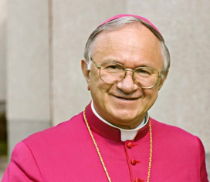

11.00

Udienza con il Santo Padre /

Audience du St-Père /

Audience with the Holy Father

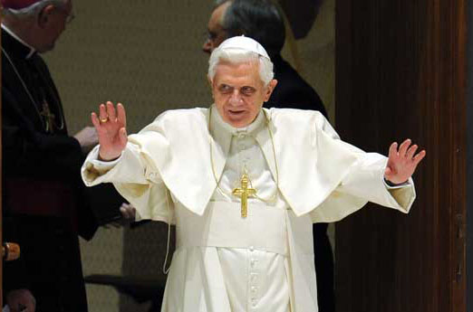

14.30: Session 5

Una divisione equa delle risorse per la sanità

Pour une répartiton équitable des ressources de santé

For an equitable division of resources for health

(Fernando Galluppi - Niklaus Waldis)

27 - Mons. Andrea Manto (Italia)

Per una cultura sanitaria a servizio dell’uomo

Pour une politique de santé au service de l'homme

For a health care culture at the service of the person

(non ricevuto / non reçu / not received)

___________________________

28 - Vincenzo-Maria Saraceni (Italia)

Implicazioni etiche nel processo di globalizzazione

Implications éthiques du processus de globalisation

Ethical implications in the globalization process

(non ricevuto / non reçu / not received)

___________________________

29 - Klaus Baumann* (Germany)

La povertà nei paesi ricchi. Come impartire cure mediche eque?

La pauvreté dans un pays riche.

Comment être équitable en matière de soins?

Poverty in a rich country. How to give equitable medical care?

* Caritas Science and Christian Social Work, Faculty of Theology, Freiburg University - Internal Senior Research Fellow of Freiburg Institute for Advanced Studies (FRIAS), Platz der Universität, 3 – D-79098 Freiburg, www.caritaswissenschaft.uni-freiburg.de, Klaus.baumann@theol.uni-freiburg.de

Also in rich countries like Germany can be verified: "The lower the socioeconomic position, the worse the health". Catholic social ethics as well as Christian social work are committed to fight not only the symptoms, but the causes of injustice, and hence the causes of the causes of disease. This contribution presents the different direct and indirect effects of socio-economic inequality on health and health-inequity as analyzed for the German context, and sketches some steps and measures towards more equitable health care in such a rich country, especially with regard to groups with high poverty risks.

___________________________

30 - Gabor Fejerdy (Hungary)

Solidarietà etica e medica / Solidarité et éthique médicale /

Solidarity and medical ethics

La solidarité et l’éthique de la santé sont des mots qui sont employés selon des sens divers et ainsi leur usage peut facilement conduire à des équivoques. Il semble donc utile de clarifier ce que nous comprenons par ces termes.

C’est à l’intérieur de notre activité de soin que nous sommes appelés à vivre selon la solidarité et les exigences éthiques, dans les diverses relations (par exemple entre médecins, entre médecin et malade etc.). En même temps, différentes forces de notre monde actuel tendent à déformer le sens de ces termes et rendent ainsi difficile notre vocation fondamentale de guérir.

La solidarité bien comprise et les exemples d’une éthique médicinale qui suivent les valeurs évangéliques présentent une solution à la solidarité déformée et à la crise éthique laquelle caractérise notre monde actuel. C’est une manière de penser chrétienne, remettant le service de la vie et de l’intégrité de l’homme au centre de sa vision, qui peut donner une réponse adéquate aux problèmes de l’éthique de santé et au manque de la vraie solidarité en ce domaine.

___________________________

Session 6 (17 Nov, 16.30)

Varie / Divers / Miscellaneous items

(Fernando Garcia-Faria-Rialp - Fausto Santeusanio)

31 - Jan Dacok, sj (Slovakia)

Post-umanesimo, cyborgs e la bioetica personalistica

Post-humanisme, cyborgs et bioéthique personaliste

Post-humanism, cyborgs and personalistic bioethics

La relazione mira alla presentazione sintetica delle caratteristiche principali dei concetti: transumanesimo, postumanesimo e organismi cibernetici (cyborgs), e mette in evidenza l’applicazione possibile di questi ultimi. Alle sfide della tecnologizzazione e della cyborgizzazione della società, presenta la posizione della bioetica personalistica, che promuove lo sviluppo e difende la dignità umana.

Transumanesimo e postumanesimo rappresentano le recenti correnti di pensiero che accettano la sostituzione dell’homo sapiens con gli esseri biologicamente e tecnologicamente superiori. L’ideale filosofico di questi movimenti è quello del Rinascimento, mescolato con il relativismo e lo scetticismo etico postmoderni. A questa visione si aggiunge una sostituzione utopica di Dio che cerca di realizzare i desideri di immortalità dell’uomo.

Il transumanesimo viene inteso come movimento filosofico e culturale che afferma le possibilità di eliminare l’invecchiamento dell’uomo e rafforzare tutte le sue capacità (l’enhancement). Secondo il postumanesimo la dignità umana è solo una illusione e per questo il corpo umano può essere sostituito. Gli “esseri postumani” sono stati tanto modificati che ormai non appartengono alla specie umana. Il termine cyborg, introdotto negli anni Sessanta, rappresenta un complesso organizzativo esogeno che funziona come un sistema omeostatico. Grazie alla ricerca, generosamente sostenuta, la linea di demarcazione tra cyborg e essere umano diventa sempre più sfumata.

Come affrontare molti e nuovi problemi etici, connessi con la medicina dell’enhancement, l’innovazione tecnologica e la trasformazione sociale? Come assicurare un progresso dal volto umano? La bioetica personalistica può contribuire a dare risposte che sono tanto attuali, anzi urgenti.

___________________________

32 - Alfredo Anzani (Italia)

Orientamenti etici nei trials clinici

Orientations éthiques dans les essais cliniques

Ethical guidelines in clinical trials

“Senza il vero bene dell’uomo, come suo fine, e senza la libertà, come sua condizione, non si dà etica” (card. Dionigi Tettamanzi).
Per bioetica, intendo la riflessione scientifica e sapienziale che considera le questioni della vita (bios) in riferimento ai valori più radicali dell'uomo nella sua specifica dignità di persona (ethos). Mi riferisco alla concezione dell'uomo inteso come persona, parametro di valore, di misura, di giudizio. Nella dignità dell'uomo inteso come persona sta il fondamentale criterio morale, oggettivo, universale, perenne. E’ bene tutto ciò che custodisce, difende, guarisce, promuove l’uomo in quanto persona. E’ male tutto ciò che lo minaccia, l'aggredisce, l'offende, lo strumentalizza, l'elimina.
La ricerca è il processo induttivo-deduttivo che mira all'osservazione sistemica di un dato fenomeno o alla verifica di un'ipotesi scaturita da precedenti osservazioni. La sperimentazione nell’uomo è un’attività necessaria al fine di studiare gli effetti causati da farmaci o da procedure, praticati a scopo diagnostico, terapeutico o preventivo. La sperimentazione clinica comporta un iter lungo e costoso, le cui diverse fasi sono descritte e stabilite dalla legge in modo da garantire procedure etiche e in grado di minimizzare i rischi per i pazienti. Per indicare le sperimentazioni cliniche si usa spesso il termine inglese clinical trials, ovvero trials clinici.
Le sperimentazioni cliniche vengono in genere effettuate nelle strutture ospedaliere/universitarie pubbliche o private autorizzate. La sperimentazione segue un percorso preciso che parte dalla cosiddetta sperimentazione pre-clinica in vitro e sugli animali d’esperimento, che giustifichino l’utilità di studiare nell’uomo un nuovo farmaco (o la nuova preparazione di un farmaco noto, o una associazione di farmaci, o una nuova indicazione terapeutica, ecc.).
Il Codice di Norimberga ricorda che è irrinunciabile il consenso informato, deve esserci un beneficio per la società non altrimenti ottenibile, evitata qualsiasi sofferenza non necessaria per i soggetti, evitato il pericolo di morte o di disabilità per i soggetti, condotta solo da personale qualificato, opportunamente preparata al fine di proteggere il soggetto, disegnata in modo tale da permettere al soggetto di ritirarsi in qualsiasi momento. La Dichiarazione di Helsinki conferma questi principi e detta regole chiare e precise
Una ricerca è etica se è veramente scientifica; se rispetta la deontologia dello scienziato e del tecnico; se rispetta e promuove i valori dell’uomo. “Il fine dell'impresa scientifica è la verità, cioè la conoscenza come bene in sé. Questo è il valore chiave della scienza” (E. Pellegrino).
“Ognuno sa che non si potrebbe condannare senza appello ogni esperimento sull'uomo in nome del rispetto della persona, in particolare quando si tratta di nuove terapie, tant'è vero che la medicina non ha spesso progredito attraverso il tempo che con laboriosi tentativi... Spetta a voi, da medici esperti, fissare le norme sempre mutevoli in questo delicato settore, senza dimenticare che il principio fondamentale dell'etica medica rimane il rispetto assoluto della vita umana” (Paolo VI, Ai medici, Washington, 1970).

___________________________

33 - Javier Sanz-Latiesas (Spain)

La relazione medico-malato nella nostra società post-moderna:

sfide e soluzioni

La relation médecin-malade dans notre société post-moderne:

défis et solutions

The doctor-patient relationship in our post-modern society:

challenges and solutions

(Conclusioni)

Cambiamenti nel raporto col paziente mediati per la dittatura della post-modernità. Necessità di ridefinire il concetto del medico buono che tende all'eccellenza per bene del malato. Importanza da vedere il malato comme globalità nella sua persona, per il miglioramento della nostra attuazione medica.

(Conclusion)

Changes in patient relations mediated by cultural change. Need to redefine the concept of good health that tends to excellence for the good of the patient. Admit the tremendous importance of the person to improve our medical interventions

___________________________

34 - Massimo Gandolfini (Italia)

Neurobiologia della coscienza

Neurobiologie de la conscience

The neurobiology of consciousness

(Conclusioni)

La ricerca scientifica, nel suo sforzo veritativo, esige che siano presenti e perseguiti contemporaneamente due aspetti essenziali della conoscenza: la componente “quantitativa”, fatta di dati empirici, e la componente “qualitativa” che affronta categorie ontologiche quali il "senso", il "significato", lo "scopo", la "causalità".

Chi e’ l’uomo? Socrate: l’uomo è l’essere che conosce sé stesso

Eschilo: l’uomo è l’essere che sfida gli dei

Platone: l’uomo è l’essere che parla degli dei

Agostino: l’uomo è l’essere che parla con Dio

Cartesio: l’uomo è l’essere che pensa sé stesso pensante

Comunque e sempre … "Homo homini sacra res" (Seneca)

___________________________

Domenica 18 / Dimanche 18 / Sunday 18

9.30
Santa Messa, presieduta da /
Sainte Messe présidée par /
Holy Mass celebrated by

Card. Tarcisio Bertone,

Segretario di Stato Vaticano





